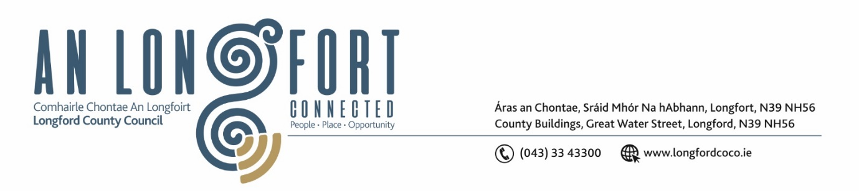

***Please note meeting will be held in the Council Chamber and via Microsoft Teams.***

3 Aibrean 2023

**Chuig: Gach Ball don Chomhairle**

A Chomhairleoir,

Iarrtar ort bheith i láthair ag Cruinniú Míosuil Chomhairle Chontae Longfoirt a tionólfar i Seomra na Comhairle, Aras an Chontae, Longford agus via MS Teams are an **Chéadaoin 12ú Aibrean 2023 ag** **3.30pm** chun gnó a dhéanamh d’réir an Chláir thíos.

You are requested to attend the Monthly Meeting of Longford County Council to be held in the **Council Chamber and via Microsoft Teams** on **Wednesday 12 April 2023 at 3.30pm** to transact business, as set out on the Agenda hereunder.

Mise le meas,

**__________________**

***Claire McNabola***

***Meetings Administrator.***

**C L Á R**

Prayer before meeting.

Presentation from representative of Iarnrod Eireann.

**1.** Confirmation of Minutes of Monthly Meeting of Longford County Council held on 8 March 2023 – copy enclosed.

**2.** Matters Arising.

**3.** Declaration of Interest by Members.

**4.** To note Management Report – to follow.

**5.** To note adopted Minutes of Corporate Policy Group Meeting held on the

7 February 2022 – enclosed.

**6. Infrastructure, Climate Action and Innovation**

**(a)** Notice of Motions, submitted by Councillors, as listed hereunder

**Councillor Paul Ross**

That all car parking machines in Longford are converted to add card only payment.

**7. Finance and Information Technology**

1. Capital Budget

**8. Housing, Planning, Regeneration & Capital Projects**

1. To note Planning Applications received since last meeting of the Council.
2. Draft Revised Development Contribution Scheme 2023-2027 - enclosed
3. Consideration of Part VIII No 103 – Road Realignment on the L 1105 at Drumanure, County Longford. Report in accordance with Section 179 of the Planning and Development Act 2000 (as amended) and Part 8 of the Planning & Development Regulations 2001 (as amended) – enclosed

**9. Community,** **Library and Cultural Services, Corporate and Human Resources**

**(a)** Consideration and adoption of Draft Annual Report 2022 – to follow

**(b)** Nominations of Elected members for the Creative Ireland Culture Team 2023-2027

**(c)** Consideration of Longford County Council nomination to the Board of Directors of Backstage Theatre

**10.**  **Correspondence**

1. Correspondence dated 20 March received from the Minister for Transport re. follow-up request to meet a representative deputation of Council members to highlight the N4 Improvement programme - enclosed
2. Correspondence dated 29 March received from the Minister for Justice re. Notice of Motion from Councillor Paul Ross regarding a ‘One-for-All’ Garda Vetting process - enclosed

**11. Training – enclosed.**

**12. Votes of Sympathy**